ASSESMENT TOOL - 1
Computer Organisation and Architecture
Application Based Questions
- YAVANIKA S
192521258

Question 1: Smart City Surveillance System — CPU, Memory, I/O and Bus Structures

Understanding the Problem
Many cameras stream video continuously through I/O devices into memory, and the CPU must fetch this data for real-time threat analysis. During peak hours, congestion in the data pathway — not raw CPU power — is what causes the delay.

How CPU, Memory and I/O Interact
- Data path: Every camera frame is transferred by an I/O controller into main memory before the CPU can process it.
- Contention: This transfer competes with the CPU's own instruction and data fetches for the same bus.
- Bottleneck: On a shared bus, only one transfer can occur at a time, so video I/O and CPU accesses queue behind each other.

Single-Bus vs Multi-Bus Structures
- Single-Bus: One shared set of address/data/control lines links CPU, memory and I/O. Simple and low-cost, but only one transfer can happen at a time — heavy camera traffic blocks CPU-memory communication.
- Multi-Bus: Separate CPU-memory and I/O buses (joined by a bridge) let camera data move into memory while the CPU works on already-buffered frames in parallel, sharply cutting contention.
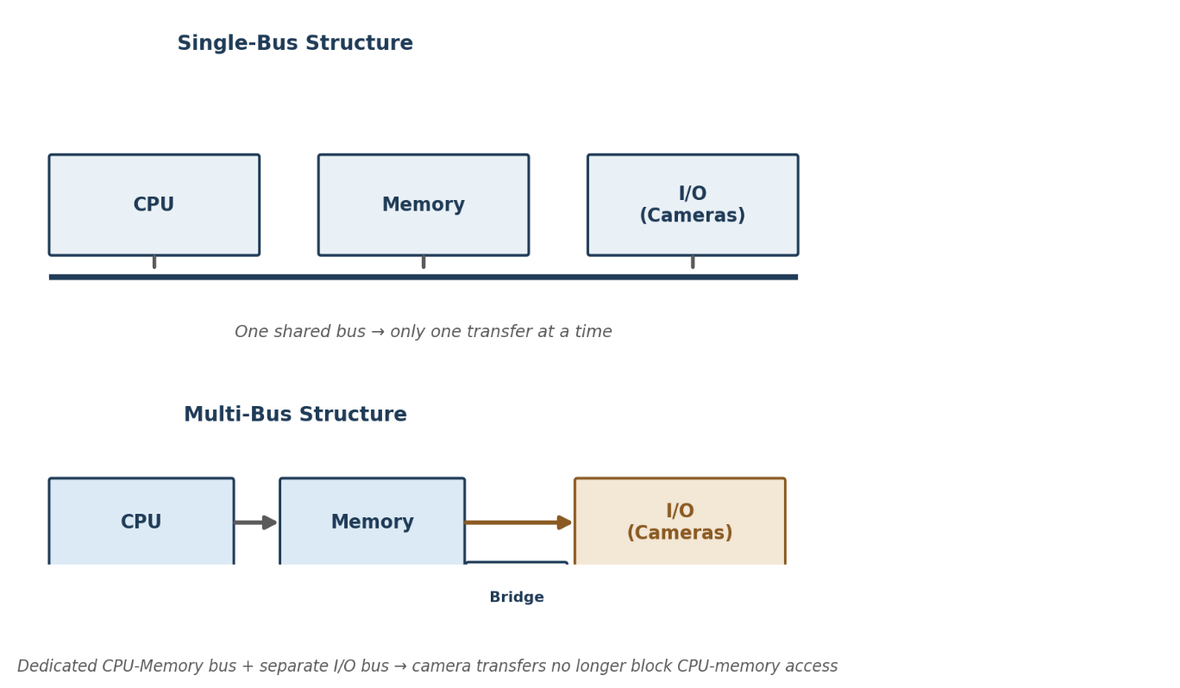
Fig 1.1 — Single-Bus vs Multi-Bus structure for CPU / Memory / I/O

Improving the Instruction Execution Cycle
- Pipelining: Overlaps fetch, decode and execute of successive instructions so the CPU is never idle waiting on memory.
- Cache memory: Placed between CPU and main memory to cut down the number of slow main-memory accesses.
- DMA: Moves camera data directly into memory without CPU involvement for every byte, freeing the CPU for threat detection.

Conclusion
The lag is caused by congested shared pathways, not CPU capacity. A multi-bus architecture with DMA-driven I/O transfer, pipelining, and caching together restore real-time responsiveness.

Question 2: Real-Time Stock Trading Application — CPI and Fetch-Decode-Execute Cycle

Understanding the Problem
Even with millions of instructions executed per second, delays appear under heavy load because CPI (Cycles Per Instruction) is high — frequent memory accesses and branch instructions make each instruction take more cycles than ideal.

Impact on the Fetch-Decode-Execute Cycle
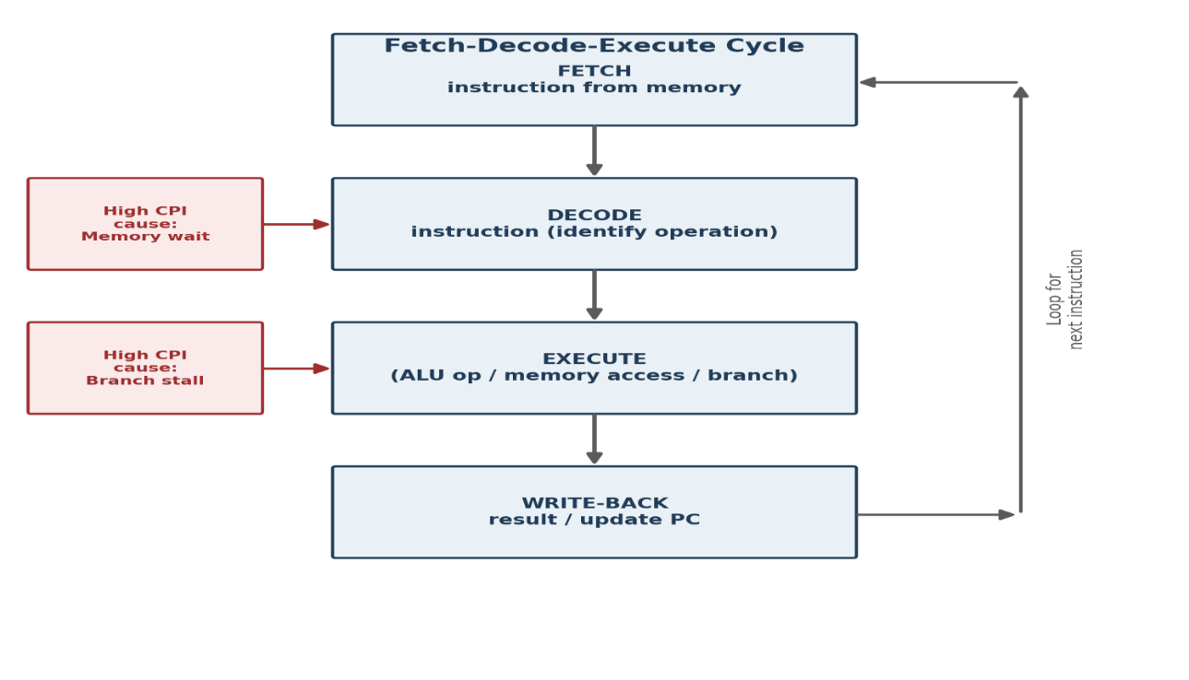
Fig 2.1 — Fetch-Decode-Execute cycle and where CPI is lost
- Formula view: Total execution time = Instruction count × CPI × Clock cycle time — so a high CPI directly inflates transaction latency.
- Memory waits: Every memory-access instruction forces the CPU to wait for data far slower than its internal clock, inflating CPI.
- Branch stalls: Conditional buy/sell logic can stall or misdirect the pipeline if the branch outcome isn't known in advance.

Reducing CPI Through Architectural Enhancements
- Caching: Multi-level cache hierarchy serves frequent data/instructions quickly instead of from slow main memory.
- Branch prediction: Predicts the likely branch outcome and pre-fetches down that path, avoiding pipeline stalls.
- Pipelining: Multiple instructions progress through different stages simultaneously, raising throughput.
- Code-level tuning: Reordering code to reduce dependent memory accesses and using registers efficiently.

Conclusion
High CPI here stems from memory-bound and branch-heavy execution. Caching, branch prediction and pipelining together bring the system closer to true real-time performance.

Question 3: 8085 Microprocessor in Industrial Temperature Control — Addressing Modes

Understanding the Problem
Sensor readings are occasionally processed incorrectly. The likely cause is improper use of addressing modes — the program ends up reading or writing the wrong register or memory location.
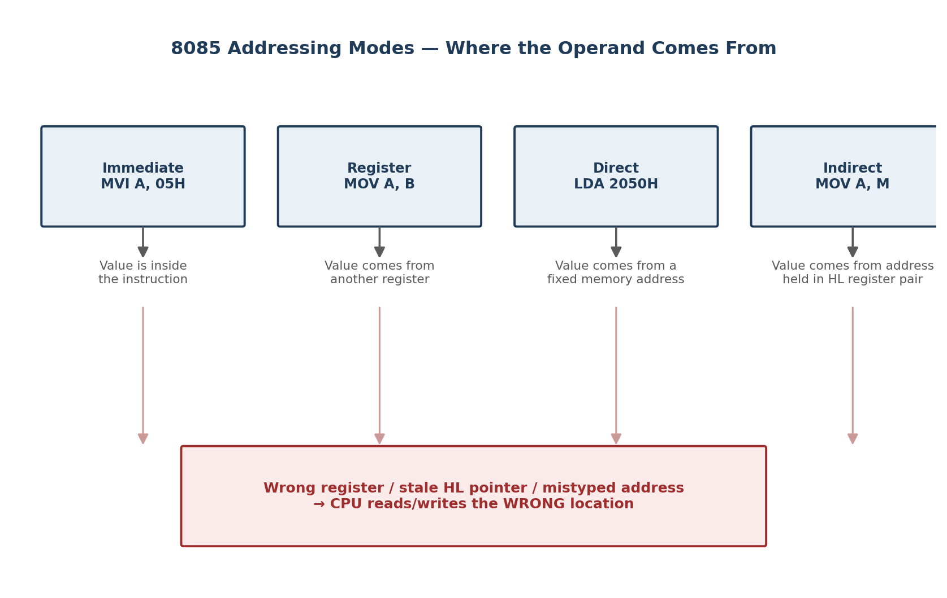
Fig 3.1 — 8085 addressing modes and where each operand comes from

Addressing Modes and Their Influence
- Immediate: MVI A, 05H — operand is fixed in the instruction; a wrong constant means a wrong threshold value every time.
- Register: MOV A, B — data moves between registers; using the wrong register mixes up unrelated values.
- Direct: LDA 2050H — a fixed memory address; a typo or overlap with another variable silently reads stale data.
- Indirect: MOV A, M — the HL register pair points to the actual address; an un-updated or stale HL reads the wrong cell entirely.

Likely Causes and Fix
- Root causes: An uninitialized or stale HL pointer, a mistyped direct address, or a register reused for two purposes without saving its value.
- Fix: Use clearly initialized pointers for indirect access, labelled addresses instead of raw numbers, and PUSH/POP around register reuse.
- Safety layer: Add compare-and-jump range checks after each sensor read so implausible values never reach the actuator.

Conclusion
Addressing modes decide exactly where data comes from. Consistent, validated indirect and direct addressing — backed by range checks — removes this class of error.

Question 4: 8086 Microprocessor — Segmented Memory Issues

Understanding the Problem
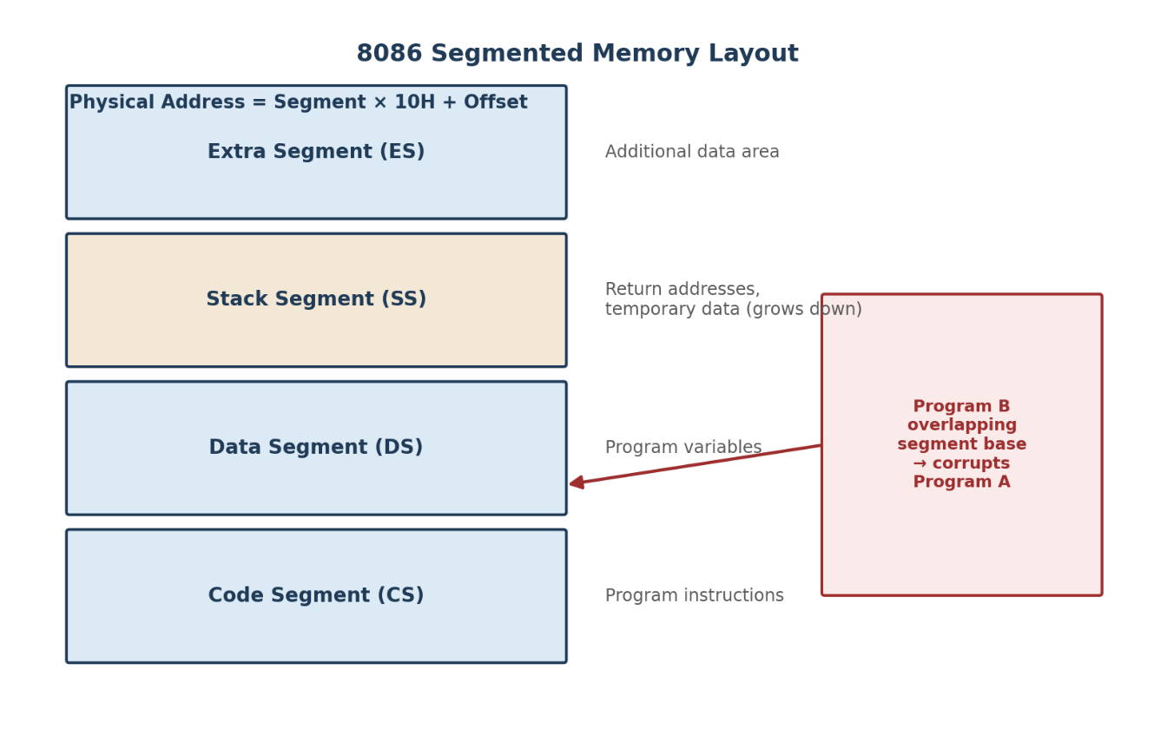
Running multiple programs on an 8086 causes incorrect data access and stack overflow, pointing to improper handling of the segmented memory model.

Fig 4.1 — 8086 segmented memory layout (CS, DS, SS, ES)

How Segmentation Works
- Addressing: Physical address = Segment × 10H + Offset, giving a 20-bit address from 16-bit segment and offset values.
- Four segments: CS (code) + IP, DS (variables), SS (stack) + SP, and ES (extra data) — each should ideally get its own non-overlapping base.

How Improper Handling Causes the Problems
- Incorrect access: Overlapping segment bases between two programs let one program's data segment collide with another's code or stack, corrupting it silently.
- Stack overflow: Unmatched CALL/PUSH without corresponding RET/POP, or too small an SS allocation, lets SP grow past its segment boundary.

Ensuring Correct Execution
- Isolation: Allocate distinct, non-overlapping segment bases per program and initialize all segment registers at start (never rely on leftovers).
- Stack discipline: Size the stack segment generously and balance every CALL/PUSH with a matching RET/POP.
- Addressing discipline: Use correct segment overrides consistently across addressing modes (direct, indexed, based) so no instruction reads the wrong segment.

Conclusion
Segmentation isolates programs only when bases don't overlap and the stack is disciplined. Proper initialization and addressing prevent the described failures.

Question 5: Number System Conversion and Reliable Data Processing

Understanding the Problem
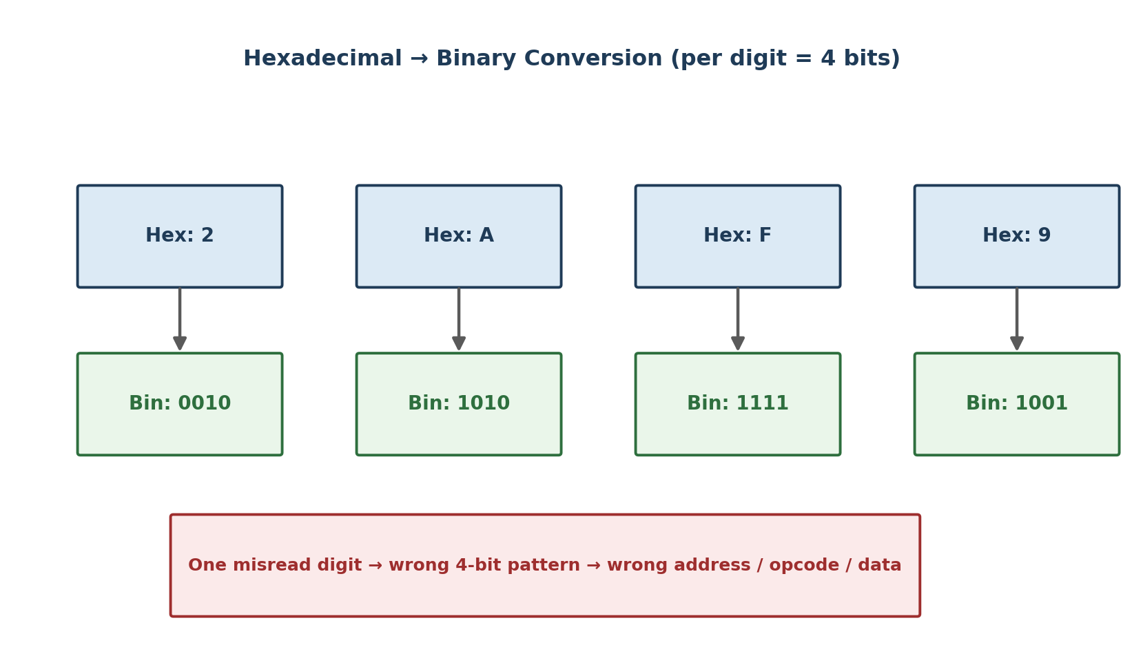
Packet data shown in hexadecimal for easy debugging is misread during conversion, leading to incorrect processing — showing how a small conversion slip can cascade into a real fault.

Fig 5.1 — Each hexadecimal digit converts to an exact 4-bit binary pattern

Importance of Hex-Binary Conversion
- Why hex: Each hex digit maps exactly to 4 binary bits, so hex compactly represents long binary strings for human debugging while converting trivially back to binary for hardware.
- Where used: Packet headers, addresses and control codes are commonly shown this way — any misread digit changes the real binary the hardware processes.

How Conversion Errors Affect Execution
- Operand field: A wrong operand value sends the CPU to fetch or write the wrong memory location.
- Opcode field: A wrong opcode/control field can cause an entirely different instruction to execute.
- System impact: In a communication system this shows up as misrouted packets, wrong checksums, or data written to the wrong buffer offset.

Role of CPU Design and Benchmarking
- CPU-level checks: Parity/checksum circuits flag a byte that doesn't match its expected pattern; memory protection limits how far an errant address can corrupt.
- Benchmarking: Running standard test workloads and comparing expected vs actual output catches conversion bugs before deployment, often visible as CPI spikes from repeated faulted accesses.

Conclusion
A single mis-converted digit changes real instructions or data. Robust CPU-level checks combined with thorough benchmarking is the practical safeguard against this class of fault.

